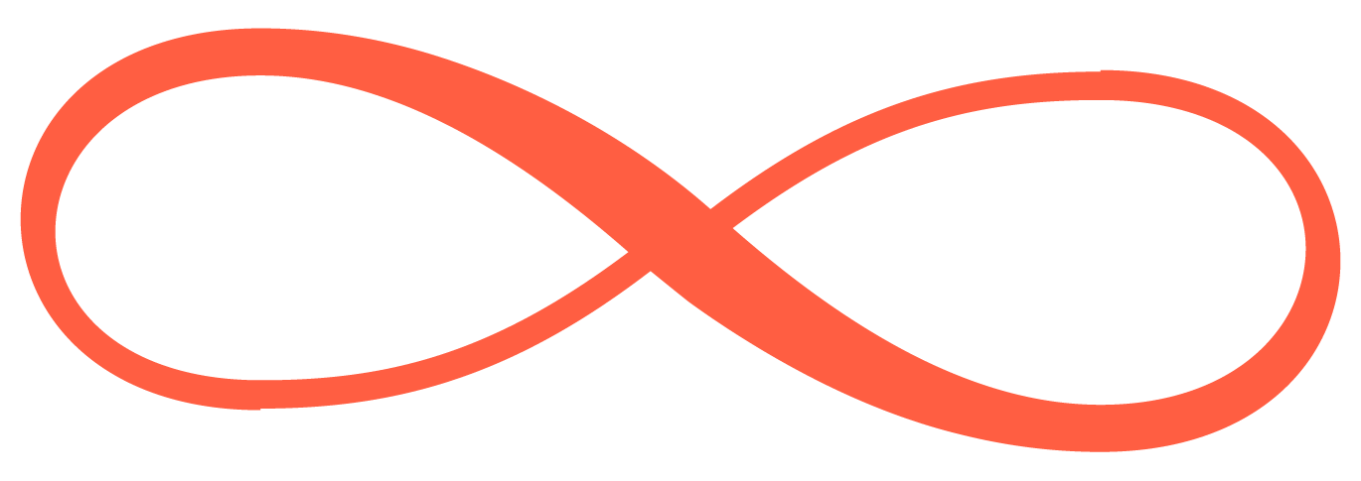
Elmé Aesthetics and Reconstructive Techniques
Rhinoplasty Discharge Instructions

Thank you for letting us be part of your journey. We know that having rhinoplasty is a big decision, and we’re honored to support you as you heal. Our team is here for you every step of the way-whether you have questions, concerns, or just need a little reassurance. Your comfort, safety, and peace of mind are what matter most to us.
How to Reach Us
Office Mon–Fri 8am–4pm: (716) 320-3563
After Hours & Weekends: (716) 214-3644
When to Call Us
Please call us right away if you notice:
- Pain that isn’t getting better, even after taking your medication
- Fever over 101°F, especially if you also have new or worsening pain, redness, swelling, or drainage from your wound
- A nosebleed that doesn’t stop after 10 minutes of gentle pressure
Taking Care of Your Nose & Dressings
- Please leave the splint on your nose and keep it dry until we see you at your follow-up. This splint is there to protect your healing nose and help shape your results.
- You may need to change the drip pad under your nose as needed for the first day or two. Some drainage is normal-don’t be alarmed.
- It’s common for your nose to feel blocked or stuffy for the first week or so. This will get better as swelling goes down.
Medications & Comfort
- Keep taking your usual medications unless we gave you different instructions.
- Gently apply a small amount of Neosporin ointment to your stitches twice a day for 7 days, or as your surgeon directs.
- For mild pain, Tylenol or Extra-Strength Tylenol is usually enough. If you need something stronger, use your prescription pain medication and always take it with food.
- Please avoid aspirin and NSAIDs (like Advil, Motrin, Aleve) for 2 days after surgery, unless Dr. Gonzalez says it’s okay.
- Only restart blood thinners when Dr. Gonzalez says it’s okay.
- If you have medicine for nausea or swelling, take it as prescribed.
- Saline spray can help keep your nose moist-start using it on day 3, as directed.

Rest, Activity & Self-Care
- Sleep on your back or side with your head propped up on 2–3 pillows. This helps with swelling and keeps you comfortable.
- Have someone you trust stay with you for the first 24 hours.
- When you bend, bend at your knees-not your waist.
- Avoid lifting anything heavier than a gallon of milk for the first week.
- Hold off on aerobic activity for two weeks, but gentle walking is encouraged.
- Don’t submerge your head in a pool or hot tub for one month.
- If you smoke, please try to avoid it for 2–4 weeks-your healing will thank you.
- Don’t drive while taking prescription pain medication.
Hygiene
- You can shower the day after surgery, but keep your splint dry. Tilt your head back to wash your hair.
- If Dr. Gonzalez asks you to, use a Q-tip dipped in hydrogen peroxide to gently clean just inside your nostrils-never insert anything deep into your nose.
- Avoid blowing your nose for at least one week.
Eating & Drinking
- Eat nourishing foods and drink plenty of fluids to help your body heal.
- For the first 48 hours, stick to cool or lukewarm drinks-hot beverages can increase swelling.
- Please avoid alcohol for two days after surgery, and while taking prescription pain medicine.
Healing Takes Time-Be Kind to Yourself
- Swelling and bruising, especially around your nose and eyes, are normal. Most of this will fade in 1–2 weeks, but the final shape of your nose will continue to refine over the coming months.
- Healing is a journey. Be gentle with yourself and give your body the time it needs.
- If you have any questions or concerns, please reach out to our team.

Thank you for letting us be part of your healing journey.

